**Create a shell script to print the HTTP error code of guvi.in & print, the success/failure message based on the error code response**

**Introduction:**

In it world of it printing and showing success the error code is 200.

This code is a successful HTTP response status code that indicates a request was successful.

It is cachable by default

However, the meaning of success depends on the request method used.

Apart from 200 API failed

**API** - Application program interface

Steps:

* First, we need to create a director then we need to change to that directory by using a cd command.
* Then, we need to create a file using the touch command. That file is in the form of .sh

Ex: **success.sh**

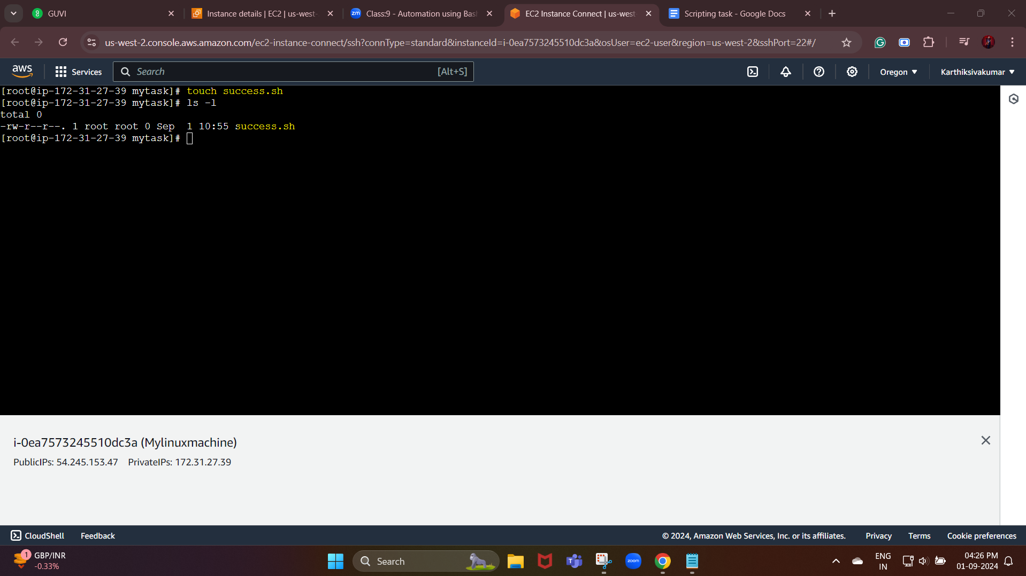

* Then, we need to open that file by using the vim command.

In that file first, we need to write a shebang

Tells the shell interpreting this script that what follows is the command that should interpret the rest of the file.

Next, we need to check whether the URL is working or not.

#!/bin/bash

# URL to check

URL="<https://www.guvi.in>"

The next step is we need to get the code

# Get the HTTP status code

HTTP_STATUS=$(curl -s -o /dev/null -w "%{http_code}" $URL)

# The curl command with:

# -o /dev/null option discards the output

# -s enables silent mode to hide progress

# -w "%{http_code}" outputs only the HTTP status code

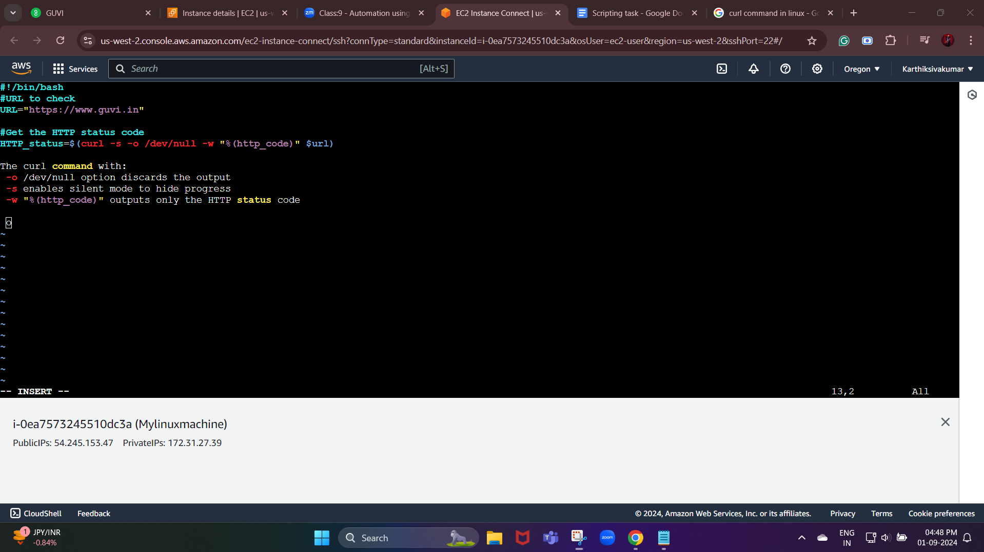

**Curl :**

curl command is used to download or upload data to a server via supported protocols such as HTTP, FTP, IMAP, SFTP, TFTP, IMAP, POP3, SCP, etc. It is a remote utility, so it works without user interaction.

The data transfer from one place to another is one of the vital and most used tasks of a computer system.

**Print the HTTP status code:**

**# Print the HTTP status code**

**echo "HTTP status code: $HTTP_STATUS"**

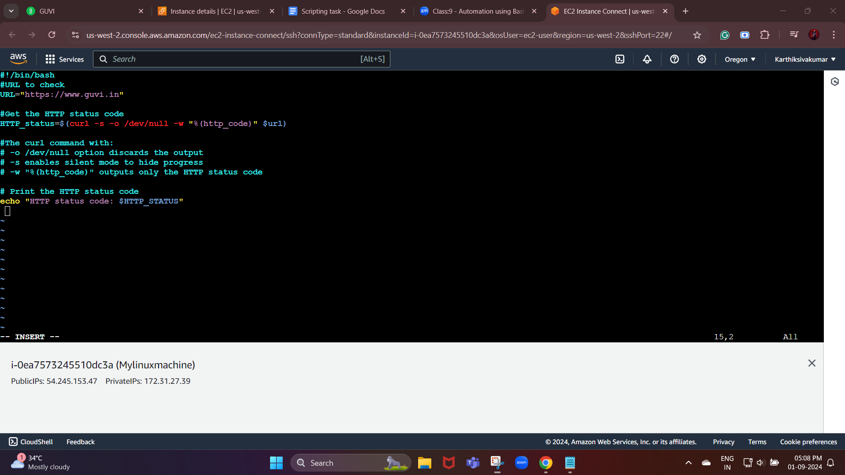

Now, we need to check the status code and print success/failure message:

We are going to validate with the if condition.

# Check the status code and print success/failure message

if [ "$HTTP_STATUS" -eq 200 ]; then

echo "Success: The website is reachable."

else

echo "Failure: The website returned an error."

fi

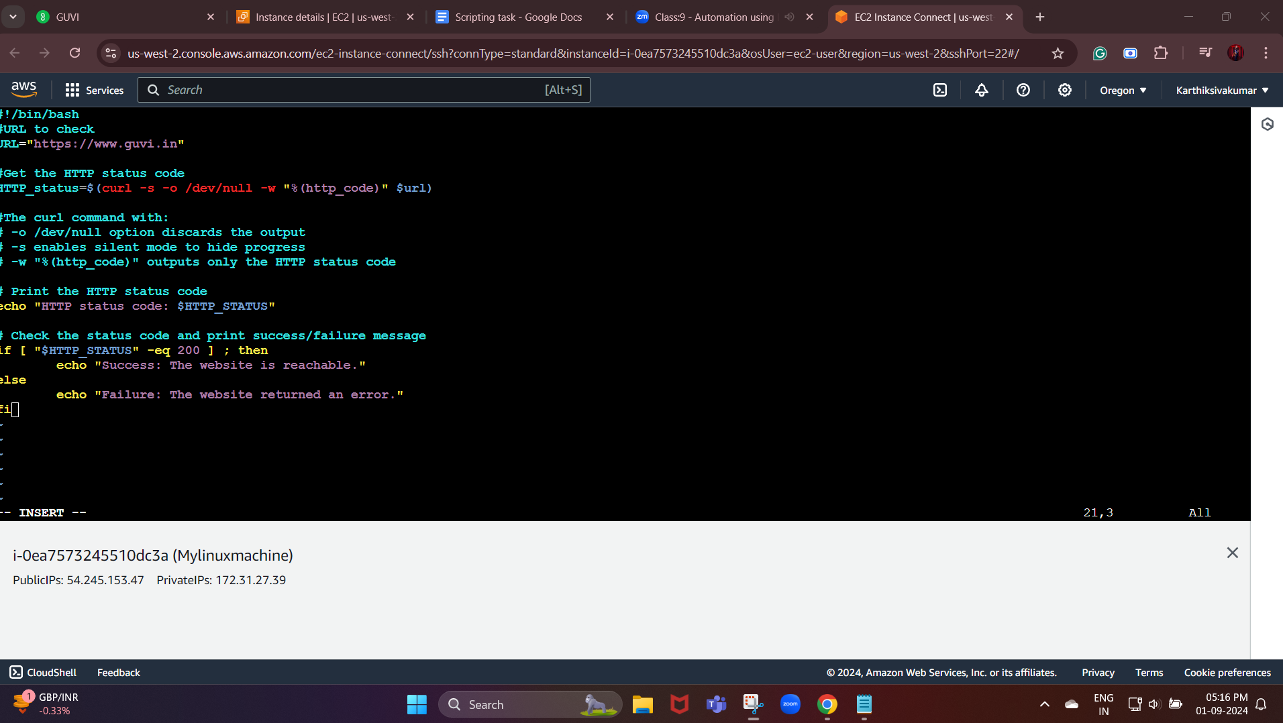

Now, we need to save and exit using:wq

Before we see the output, we need to give permission to that file.

Command:

chmod +x success.sh

Now, we need to use the command

./success.sh

We get the final result

The website is reachable

HTTP status code: 200

